**MALL INTRO SECTION**

Glory pictures of status Mall in a carousel style, set to rotate automatically.

**Not just retail.**

**This is 9 storeys of luxury.**

*Mogra Status is not your ordinary mall.*

*It’s where sophistication meets scale. Style meets service that’s unrivalled.*

*And shopping is one more occasion for Noida’s most affluent to indulge in life’s finest pleasures.*

*This is your exclusive chance to invest and belong in the same circle.*

**…**

**The space. The ambition.**

**The investment opportunity.**

*We set the tallest standard.*

* + A landmark project designed by acclaimed architects of Dubai Mall.
  + Primely located in a sought-after area frequented by Noida’s elite.
  + Elevated brand presence in a space synonymous with high-end retail.
  + Limited-time opportunity to secure prime spaces at exclusive rates.
  + Early access to Noida’s thriving growth story.

**…**

**Highlights**

**Project Name**   
Mogra Status

**Developer**

Mogra Realty

**Designed By**

World-celebrated DP architects of Singapore

**Area**

1.4 million square feet

**Price**

On request

**Retail Suite Configurations**

Customisable, double-height spaces

**Current Status**

New Launch

***[Below contact section is a sidebar designed to sit next to highlights section]***

**Request Your Access**

Name:

Mobile:

Email:

**…**

**LOCATION SECTION:**

**An address so influential,**

**commanding attention is easy.**

*Sector 129, Noida Expressway*

Minutes away from premium residential communities.

Undisturbed access to Jewar Airport, South Delhi via DND Flyway.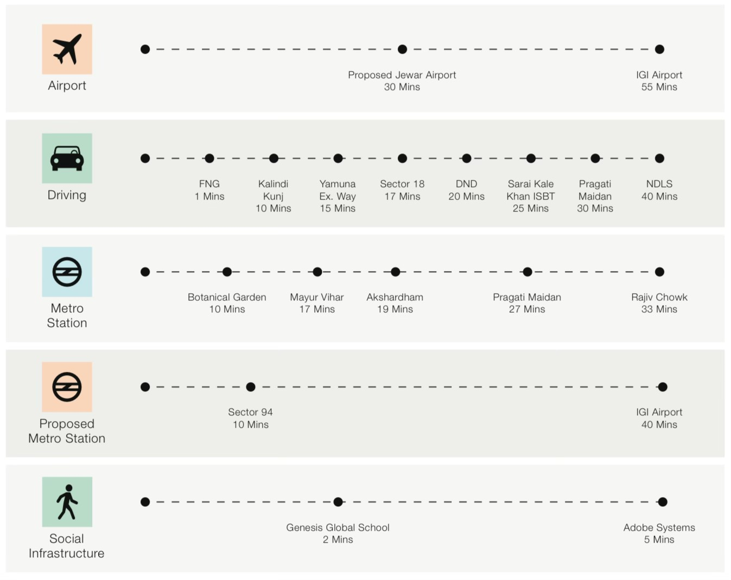

**…**

**International-standard retail amenities.**

**Taken to new heights.**

***[Shown with icons]***

*An unparalleled collection of global brands and exclusive experiences.*

*50+ gourmet dining options to delight every palate.*

*An exclusive floor reserved for designer bridal-wear.*

*A 6-screen multiplex ready to seat 1,300+ movie lovers.*

*Store-side parking across floors 4th to 9th.*

*Rooftop restobars and dining overlooking the Expressway & Golf course.*

*Floor dedicated to wellness clinics and cosmetic med-spas.*

*State-of-the-art security and smart shopping solutions.*

**…**

**FLOOR PLANS**

***[Carousel of floor wise plans of all 9 floors]***

**…**

**Mogra Realty**

At Mogra Realty, we build more than structures – we build futures.

We’re passionate about crafting exceptional spaces that elevate urban life, enrich lives, and inspire meaningful connections. At the heart of everything we do is a dedication to elevating the human experience through thoughtful, people-centered design and future-forward thinking.

**…**

**The Mogra Promise**

*[To be accompanied with icons]*

Marquee locations in prime areas

Modern, innovation-first designs

Uncompromising focus on precision

Superior materials and construction

Wellness-promoting green spaces

Next-generation amenities

**…**

Bottom Banner:

**Address Sales Inquiry We are Social**

Noida, Delhi +91 9xxxxxxxxx Icons: Instagram, X, LinkedIn